1.

根据ai给出代码，在plantuml网站上运行得

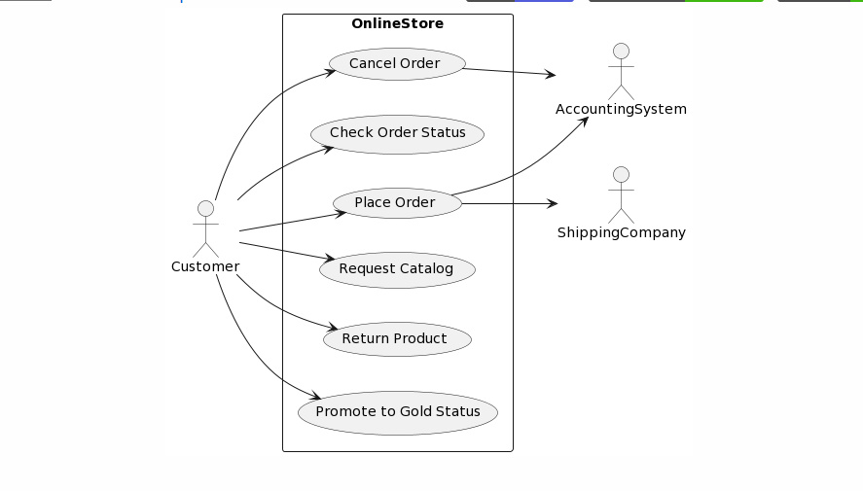

进过我的优化后得到方案如下所示

经过优化后新增了GoldCustomer的actor,因为明显黄金顾客不能再参与提升为黄金地位的用例，所以应该与普通顾客区分开来。

That is how I question GPT. The following is GPT’s answer.

@startuml

class Customer {

-customerNumber: int

-name: String

-address: String

-goldCustomer: boolean

+getCustomerNumber(): int

+getName(): String

+getAddress(): String

+isGoldCustomer(): boolean

+placeOrder(cart: ShoppingCart): Order

+checkOrderStatus(order: Order): String

+cancelOrder(order: Order): void

+requestCatalog(): Catalog

+returnProduct(order: Order): void

}

class Product {

-productNumber: int

-description: String

-price: double

-picture: Image

-available: boolean

+getProductNumber(): int

+getDescription(): String

+getPrice(): double

+getPicture(): Image

+isAvailable(): boolean

+setAvailable(available: boolean): void

}

class ShoppingCart {

-items: List<Item>

+addItem(product: Product, quantity: int): void

+removeItem(product: Product, quantity: int): void

+getItems(): List<Item>

}

class Item {

-product: Product

-quantity: int

+getProduct(): Product

+getQuantity(): int

+setQuantity(quantity: int): void

}

class Order {

-orderNumber: int

-customer: Customer

-cart: ShoppingCart

-shippingAddress: String

-creditCardNumber: String

-billingAddress: String

+getOrderNumber(): int

+getCustomer(): Customer

+getCart(): ShoppingCart

+getShippingAddress(): String

+getCreditCardNumber(): String

+getBillingAddress(): String

+getTotalCost(): double

}

interface Catalog {

+getProducts(): List<Product>

+getProduct(productNumber: int): Product

}

class WebCatalog implements Catalog {

-products: List<Product>

+getProducts(): List<Product>

+getProduct(productNumber: int): Product

}

class GoldCustomerController {

+extendReturnPeriod(order: Order): void

+getNewBonusPoints(order: Order): int

+sendEmailNotification(order: Order): void

}

class ShippingCompanyController {

+fulfillOrder(order: Order): void

}

class AccountingSystemController {

+generateInvoice(order: Order): Invoice

}

class Invoice {

-orderNumber: int

-customer: Customer

-totalCost: double

-creditCardNumber: String

-billingAddress: String

+getOrderNumber(): int

+getCustomer(): Customer

+getTotalCost(): double

+getCreditCardNumber(): String

+getBillingAddress(): String

}

Customer --> ShoppingCart

Customer --> Order

Customer --> Catalog

Order --> GoldCustomerController

Order --> ShippingCompanyController

Order --> AccountingSystemController

Catalog <|.. WebCatalog

GoldCustomerController ..> Order

ShippingCompanyController ..> Order

AccountingSystemController ..> Order

Order --> Invoice

Invoice --> Customer

@endum

这太乱了，而且存在很多逻辑不同，但类定义及方法很值得参考，经过优化后的方案如下所示：

3.

做得很好，需要修改一下上面的类名，得到结果如下

